Trailhunter Concept Previews New Grade Of Toyota Trucks at SEMA Show

November 01, 2022

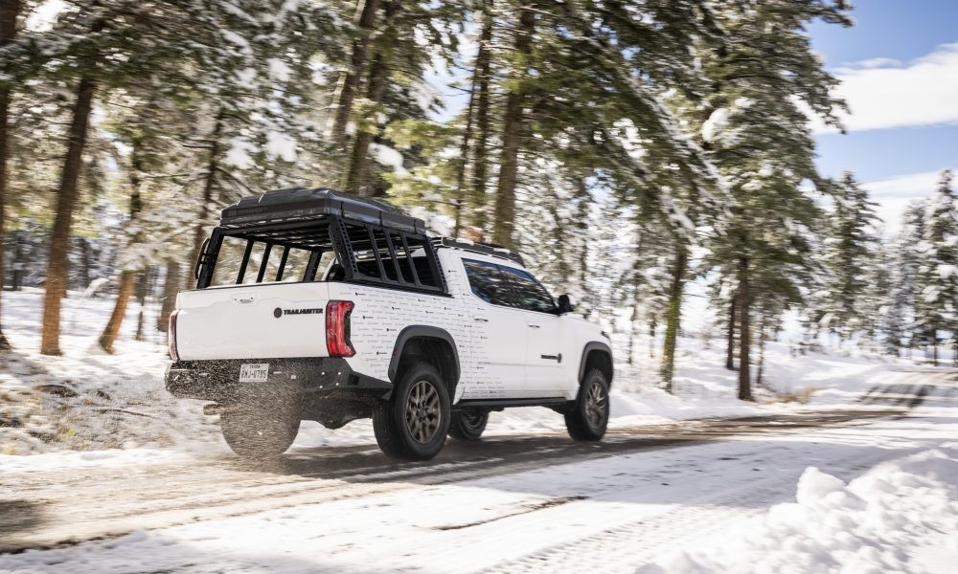

**LAS VEGAS (Nov. 1, 2022)** – Toyota announced the new Trailhunter grade of trucks with the unveiling of the Trailhunter Concept at the 2022 Specialty Equipment Market Association Show (SEMA). Trailhunter will strengthen Toyota’s commitment to the overlanding community and take its legendary go-anywhere credentials to the next level. Toyota is planning to offer purpose-built trucks and SUVs under the Trailhunter name to outdoor enthusiasts who long for off-the-grid expeditions. Trailhunter will serve as a flagship offering to inspire and support modifications of Toyota trucks with Toyota Genuine or Associated Accessory Products equipment across the lineup.

“Trailhunter trucks will come straight from the factory equipped to meet the needs of overlanding enthusiasts,” said Lisa Materazzo, group vice president – Toyota Division Marketing. “These trucks will be developed in- house by our engineering teams and will be the most capable OEM overlanding solutions designed to meet Toyota’s legendary quality, durability and reliability standards.”

Building on Toyota’s proven trucks and SUVs, Trailhunter vehicles will be highly capable, intentionally designed overlanding rigs. The all-new Trailhunter product line is designed to meet the demands of outdoor enthusiasts who love to explore with their vehicle. Designed and developed in-house at Toyota, Trailhunter

vehicles will be adventure ready straight from the factory, providing a trail-ready truck with components and accessories that support a remote off-the-grid experience.

The Trailhunter concept vehicle showcases Toyota’s vision of what this new grade of truck could look like right off the dealer lot including available Associated Accessory Products. The concept truck on display at the 2022 SEMA Show is equipped with a Trailhunter-specific suspension setup, skid plates, roof rack, bumpers, lighting, refrigerator, rooftop tent and more all engineered specifically for overlanding applications. Enthusiasts can expect future Trailhunter products to deliver terrain versatility and protection as well as load-bearing performance and storage functionality for their equipment, recovery gear and base camp necessities.

Year after year at the SEMA Show, Toyota has demonstrated its commitment to performance, excitement and fun. Toyota has shown its strong devotion to outdoor enthusiasts through overlanding concepts such as the [Tacozilla Tacoma Camper](https://pressroom.toyota.com/toyota-unveils-tacozilla-tacoma-camper-overlanding-rig-at-2021-sema-show/), [the TRD Sport Trailer](https://pressroom.toyota.com/toyota-displays-its-trd-sport-trailer-ultimate-overlanding-trailer-at-sema/) and [the Tacoma Overlanding Concept](https://pressroom.toyota.com/toyota-unveils-tacoma-overlanding-concept-at-sema/). Trailhunter will take that commitment to the next level.

Toyota will share additional Trailhunter details next year. Every truck will be designed from the ground up to include the overlanding modifications and components enthusiasts expect. The Trailhunter badge – which resembles a compass to reinforce that the journey is the main purpose – will represent the vehicle’s bona fide credentials as a highly functional and purpose-built overlanding rig.

Toyota is displaying an array of featured vehicles and build concepts along with a variety of production cars, SUVs and trucks in its SEMA Show exhibit (Central Hall, Booth No. 22200) at the Las Vegas Convention Center Nov. 1-4, 2022.

*Vehicle described is a special project prototype vehicle, modified with parts and/or accessories not available from Toyota may void the vehicle’s warranty, may negatively impact vehicle performance and safety, and may not be street legal.*